Indian Place Value Chart
Place value tells us the value of each digit in a numeral based on its position. A place value chart helps us to recognize large numbers. We read place value chart from left to right. In Indian system we start grouping the number from right in group of 3 and further in group of 2.The place value chart have been separated into groups called periods i.e. ones, thousands, lakhs and crores.
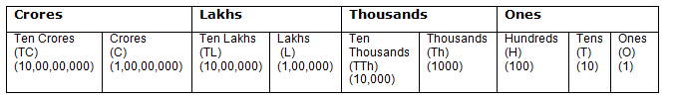
Let’s read this number according to Indian Place Value Chart.
3,56,245 – Three lakh fifty six thousand two hundred forty five
1,23,50,005- One crore twenty three lakh fifty thousand five

